Some notes on the tool we reviewed earlier. The RFQ document has a mix of requirements some a purely contract related but there are a lot of software related requirements that are important to capture.
I just reviewed the first page.
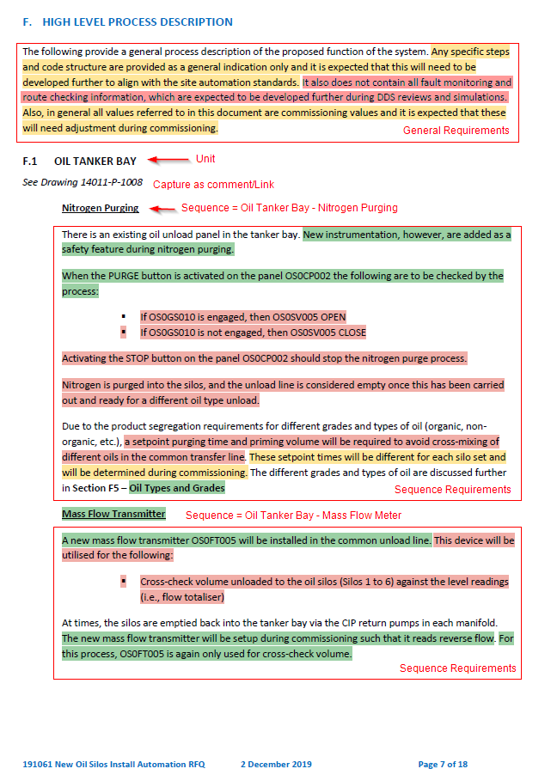

Key:
Green highlight = requirement captured by tool, flagged as “Build”
Orange highlight = requirement captured by tool flagged as “detected, awaiting engineer triage”
Red highlight = missed by tool

All sentences should probably be captured and linked to an area or sequence.
All requirements should then be triaged and can be moved or linked to more than one unit/sequence.
Requirements should be able to be categorised as requirement (testable) or observation (information only).
These requirements need to be linked to tests and the ability to add them to test reports for signoff.
General requirements should be linked to all units/sequences.
As part of the triage process, we need the ability to create new requirements as they almost never capture them all.
Units/sequences should be created with a preliminary name based on the section headings.
Maybe create a short tag name based on the initials eg. OTB-MFM - Description - Oil Tanker Bay – Mass Flow Meter
This name and description need to be easily changed later.

Maybe we could then process the drawings after first adding some manual markup like this:
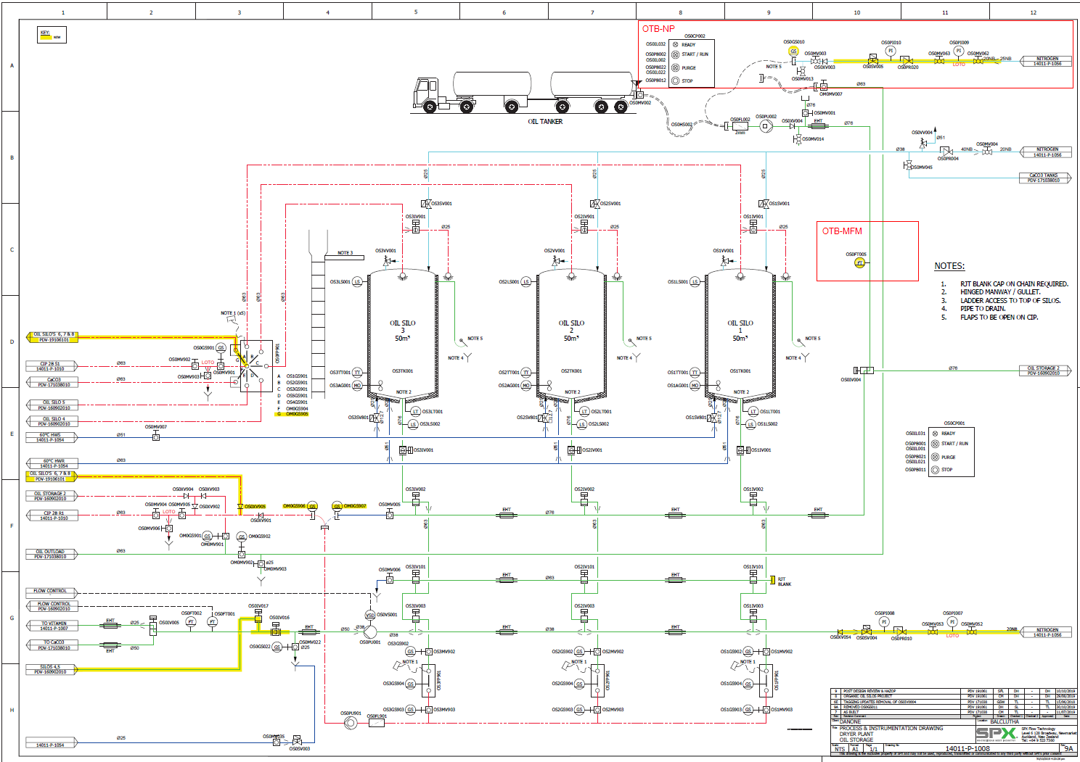

You will still get some false positives but hopefully it will be easier to run through them and discard them.
Problem is these sequences often have big doglegs in them and run across multiple drawings.
Maybe this manual markup process could help the processing of the RFQ as well. If we add comments like “Unit Name” and “Sequence Name” etc.
Sometimes these documents don’t have unit headings, but they almost always have some sort of sequence name heading.

Just some thoughts from my quick look today.

